# Практическая работа №2

Студент: Болдинов Алексей ЭФМО-02-24

1. Выбрать рейсы из города А в город Б

SELECT departure, arrival FROM flight

JOIN route ON flight.route_id = route.id

JOIN city cA ON route.from_country_id = cA.id

JOIN city cB ON route.to_country_id = cB.id

WHERE cA.name = 'zrenjanin' AND cB.name = 'larissa';

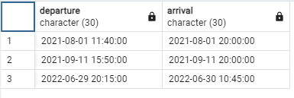

1. Выбрать промежуточные станции для определенного рейса

SELECT city.name FROM city

JOIN intermediate_stations ON intermediate_stations.city_id = city.id

JOIN flight ON flight.id = intermediate_stations.flight_id

JOIN route ON flight.route_id = route.id

WHERE route.train_number = 'J5189' AND flight.departure = '2021-04-12 18:00:00';

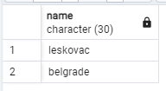

1. Выбрать номера поездов, которые останавливаются на указанной промежуточной станции

SELECT route.train_number FROM route

JOIN flight ON flight.route_id = route.id

JOIN intermediate_stations ON intermediate_stations.flight_id = flight.id

JOIN city ON intermediate_stations.city_id = city.id

WHERE city.name = 'patras'

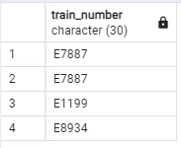

1. Выбрать типы вагонов, которые есть на определенном рейсе

SELECT ticket.type_of_wagon FROM ticket

JOIN flight ON ticket.flight_id = flight.id

JOIN route ON flight.route_id = route.id

WHERE route.train_number = 'E8934'

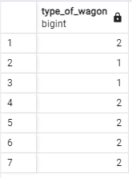

1. Вывести количество свободных мест на определенный рейс

SELECT count(ticket.status) FROM ticket

JOIN flight ON ticket.flight_id = flight.id

JOIN route ON flight.route_id = route.id

WHERE route.train_number = 'E8934'and flight.departure = '2021-01-27 15:00:00' and ticket.status = 1

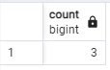

1. Рассчитать среднюю стоимость места в вагоне-купе для поездов из города А в город Б

SELECT AVG(ticket.cost) FROM ticket

JOIN flight ON ticket.flight_id = flight.id

JOIN route ON flight.route_id = route.id

JOIN city cA ON cA.id = from_country_id

JOIN city cB ON cB.id = to_country_id

WHERE cA.name = 'belgrade' and cB.name = 'vranje' and ticket.type_of_wagon = 1

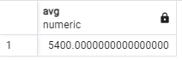

1. Вывести стоимость самого дорогого билета для поезда отправляющегося в указанную дату

SELECT MAX(ticket.cost) FROM ticket

JOIN flight ON ticket.flight_id = flight.id

WHERE flight.departure = '2021-01-27 15:00:00'

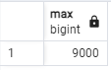

1. Вывести количество свободных нижних мест в плацкарте на указанный рейс (нижние места имеют нечетный номер)

SELECT count(ticket.id) FROM ticket

JOIN flight ON ticket.flight_id = flight.id

WHERE flight.departure = '2022-04-02 00:10:00'

and ticket.number_of_wagon % 2 = 1 and ticket.type_of_wagon = 1

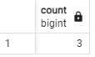

1. Вывести минимальную стоимость билета в купе поезда, проезжающего указанную промежуточную станцию в определенную дату

SELECT MIN(ticket.cost) AS min_cost,

route.train_number,

cA.name AS from_city,

cB.name AS to_city

FROM ticket

JOIN flight ON ticket.flight_id = flight.id

JOIN route ON flight.route_id = route.id

JOIN city cA ON route.from_country_id = cA.id

JOIN city cB ON route.to_country_id = cB.id

JOIN intermediate_stations ON intermediate_stations.flight_id = flight.id

JOIN city cI ON intermediate_stations.city_id = cI.id

WHERE flight.departure = '2021-01-27 15:00:00'

AND ticket.type_of_wagon = 2

AND cI.name = 'vranje'

GROUP BY route.train_number, cA.name, cB.name;

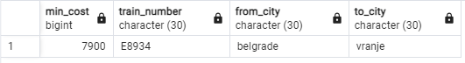

1. Вывести номера поездов, которые останавливаются на указанной промежуточной станции, в течение последующих 90 суток

SELECT route.train_number,

flight.departure

FROM flight

JOIN route ON flight.route_id = route.id

JOIN intermediate_stations ON intermediate_stations.flight_id = flight.id

JOIN city cI ON intermediate_stations.city_id = cI.id

WHERE cI.name = 'patras' -- Замените 'vranje' на название нужной промежуточной станции

AND intermediate_stations.date_from

BETWEEN TO_TIMESTAMP('2022-01-01 00:10:00', 'YYYY-MM-DD HH24:MI:SS')

AND TO_TIMESTAMP('2022-01-01 00:10:00', 'YYYY-MM-DD HH24:MI:SS') + INTERVAL '1 year'

ORDER BY flight.departure ASC;

